Game Programming Practical Midterm Name_______________________________

**Breakout**

**Game Requirements**

**Blocks** disappear when hit by the ball

some blocks may need to be hit more than once*

when a block disappears the player gets 1 pt

**BlockManager** to lay out blocks

Load blocks into block manager

Arrange block in pattern

Notify player when no more block are left

load new level once all blocks are gone*

Level may speed up ball when new level is loaded

**Paddle** moves with input component or inputController

paddle won't move off screen left or right

paddle speed or distance from center point may influence reflection angle*

paddle may have multiple sizes based on level or powerup*

**Ball** class

ball bounces off left right and top of screen

ball bounces off of blocks

ball bounces off of paddle

paddle hit area should only be top of paddle*

player losses ball when ball touches bottom of screen

player gets three balls per game*

**Game** class uses components to add object to the game

Uses inputHandler to help separate input code from game components

**ScoreManager**

displays score

displays remaining paddles

displays level

*indicates preferred features but not necessary for passing grade

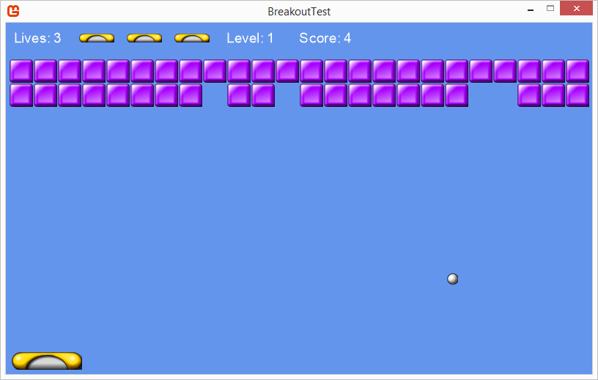

You can use any internet or class resources you like other than asking each other or someone else for help.

You can ask me for help or specific questions if you get stuck. I will deduct points based on the amount of help you need.